Linear Regression in Machine Learning

Linear regression is one of the easiest and most popular Machine Learning algorithms. It is a statistical method that is used for predictive analysis. Linear regression makes predictions for continuous/real or numeric variables such as **sales, salary, age, product price,** etc.

Linear regression algorithm shows a linear relationship between a dependent (y) and one or more independent (y) variables, hence called as linear regression. Since linear regression shows the linear relationship, which means it finds how the value of the dependent variable is changing according to the value of the independent variable.

The linear regression model provides a sloped straight line representing the relationship between the variables. Consider the below image:

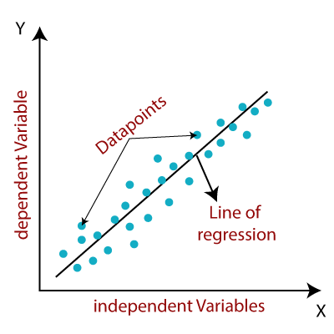

Mathematically, we can represent a linear regression as:

y= a0+a1x+ ε

**Here,**

Y=Dependent Variable (Target Variable)  
X=ndependent Variable (predictor Variable)  
a0= intercept of the line (Gives an additional degree of freedom)  
a1 = Linear regression coefficient (scale factor to each input value).  
ε = random error

The values for x and y variables are training datasets for Linear Regression model representation.

Types of Linear Regression

Linear regression can be further divided into two types of the algorithm:

**1] Simple Linear Regression:**  
If a single independent variable is used to predict the value of a numerical dependent variable, then such a Linear Regression algorithm is called Simple Linear Regression.

**2]MultipleLinearregression:**  
If more than one independent variable is used to predict the value of a numerical dependent variable, then such a Linear Regression algorithm is called Multiple Linear Regression.